Project Report Format
1. INTRODUCTION
1.1 Project Overview
1.2 Purpose
2. IDEATION PHASE
2.1 Problem Statement
2.2 Empathy Map Canvas
2.3 Brainstorming
3. REQUIREMENT ANALYSIS
3.1 Customer Journey map
3.2 Solution Requirement
3.3 Data Flow Diagram
3.4 Technology Stack
4. PROJECT DESIGN
4.1 Problem Solution Fit
4.2 Proposed Solution
4.3 Solution Architecture
5. PROJECT PLANNING & SCHEDULING
5.1 Project Planning
6. FUNCTIONAL AND PERFORMANCE TESTING
6.1 Performance Testing
7. RESULTS
7.1 Output Screenshots
8. ADVANTAGES & DISADVANTAGES
9. CONCLUSION
10. FUTURE SCOPE
11. APPENDIX
Source Code(if any)
Dataset Link
GitHub & Project Demo Link
1. INTRODUCTION
1.1 Project Overview
Rising Waters – AI Flood Prediction System is an intelligent web-based application designed to predict flood risks using Machine Learning techniques and real-time environmental data. The system analyzes important parameters such as rainfall, river water level, humidity, temperature, and weather conditions to estimate the probability of flooding. Based on the prediction results, the application provides early flood warnings and safety recommendations to help individuals and local authorities prepare for potential flood situations. The system aims to improve disaster preparedness, reduce property damage, and protect human lives through timely and accurate flood prediction.

1.2 Purpose
The primary purpose of this project is to develop an AI-powered flood prediction system that assists users in identifying potential flood risks before they occur. The application enables users to make informed decisions by providing accurate flood probability predictions, real-time alerts, and safety recommendations. By utilizing Machine Learning algorithms and weather-related data, the system contributes to disaster management, enhances public safety, and supports proactive emergency response.

2. IDEATION PHASE

2.1 Problem Statement
Floods are among the most destructive natural disasters, causing significant loss of life, property damage, and environmental impact every year. Existing warning systems often fail to provide timely, accurate, and localized predictions, making it difficult for communities to prepare in advance. People living in flood-prone areas require a reliable system that can analyze environmental conditions and predict potential flood risks before they occur. The proposed Rising Waters – AI Flood Prediction System addresses this challenge by utilizing Machine Learning algorithms and real-time weather data to provide accurate flood predictions, early warnings, and safety recommendations.

2.2 Empathy Map Canvas
The empathy map was developed to understand the needs, concerns, behaviors, and expectations of people living in flood-prone regions. Users require accurate flood predictions, timely alerts, and reliable weather updates to ensure the safety of their families and property. They often monitor weather forecasts, follow government advisories, and prepare emergency kits during heavy rainfall. By understanding their perspective, the proposed solution focuses on delivering a simple, reliable, and intelligent flood prediction system that supports informed decision-making during emergencies.

2.3 Brainstorming
During the brainstorming phase, several ideas were evaluated to identify the most effective solution for flood prediction. The team discussed approaches such as IoT-based flood monitoring, satellite image analysis, weather forecasting systems, and Machine Learning-based prediction models. After evaluating feasibility, cost, scalability, and implementation complexity, the team selected a Machine Learning-based web application that predicts flood risk using environmental parameters. This solution was chosen because it provides accurate predictions, is cost-effective, easy to deploy, and offers real-time decision support for disaster preparedness.
3. REQUIREMENT ANALYSIS
3.1 Customer Journey Map
The customer journey begins when a user notices heavy rainfall or receives weather updates indicating possible flooding. The user opens the Rising Waters application, enters the required environmental information or retrieves live weather data, and requests a flood prediction. The system processes the information using the Machine Learning model and displays the flood probability along with safety recommendations. Based on the prediction, the user can take preventive actions such as preparing emergency supplies, avoiding high-risk areas, or following evacuation guidelines.

3.2 Solution Requirements
The proposed system requires reliable environmental data, a trained Machine Learning model, internet connectivity, and a web-based interface for users. Functional requirements include flood prediction, weather data retrieval, early warning generation, and dashboard visualization. Non-functional requirements include high prediction accuracy, system reliability, quick response time, data security, and an intuitive user interface.

3.3 Data Flow Diagram
The Data Flow Diagram (DFD) illustrates the movement of data within the Rising Waters system. Users provide environmental parameters or request live weather information. The application processes this data using the Machine Learning model and stores relevant information in the database. The prediction results are then displayed to users along with flood alerts and safety recommendations. The DFD ensures a clear understanding of how information flows between users, system components, APIs, and the database.

3.4 Technology Stack
The Rising Waters application is developed using Python, Flask, HTML, CSS, and JavaScript for the web application. Scikit-learn, Pandas, and NumPy are used for Machine Learning model development and data processing. Weather information is obtained through external APIs, while SQLite is used for data storage. The project is managed using Git and GitHub, and can be deployed on cloud platforms such as Render or Railway.
4. PROJECT DESIGN
4.1 Problem Solution Fit
Flood-prone communities require a reliable and intelligent system that can predict flood risks before disasters occur. The proposed Rising Waters – AI Flood Prediction System addresses this challenge by analyzing environmental and weather parameters using Machine Learning. It provides early warnings, accurate flood probability predictions, and safety recommendations, enabling users to take preventive actions and minimize loss of life and property.

4.2 Proposed Solution
The proposed solution is an AI-powered web application that predicts flood probability based on rainfall, river water level, humidity, temperature, and other environmental factors. Users can enter environmental parameters or retrieve weather information through APIs. The Machine Learning model processes the data and displays flood risk levels along with alerts and preparedness recommendations through an intuitive dashboard.

4.3 Solution Architecture
The solution follows a layered architecture. The frontend is developed using HTML, CSS, and JavaScript to provide an interactive user interface. The backend is implemented using Flask, which communicates with the Machine Learning model developed in Python using Scikit-learn. Weather APIs supply real-time environmental data, while SQLite stores prediction history and user information. The processed results are displayed to users through the web application.
5. PROJECT PLANNING & SCHEDULING
5.1 Project Planning
The development of the Rising Waters – AI Flood Prediction System was carried out in multiple phases. Initially, the project requirements were gathered and analyzed, followed by data collection and preprocessing. A Machine Learning model was then developed, trained, and evaluated using historical environmental data. The web application interface was implemented using Flask, HTML, CSS, and JavaScript. Finally, the complete system underwent functional and performance testing before deployment.

6. FUNCTIONAL & PERFORMANCE TESTING
6.1 Performance Testing
The system was tested using different environmental conditions and weather data to evaluate prediction accuracy, response time, and reliability. Functional testing confirmed that all features, including flood prediction, weather data retrieval, dashboard visualization, and safety alerts, worked correctly. Performance testing showed that the application generates predictions within a few seconds while maintaining consistent accuracy and stability.

7. RESULTS
7.1 Output Screenshots
The developed application successfully predicts flood probability based on environmental parameters and displays the results through a user-friendly dashboard. The prediction output includes flood risk level, probability percentage, and safety recommendations.

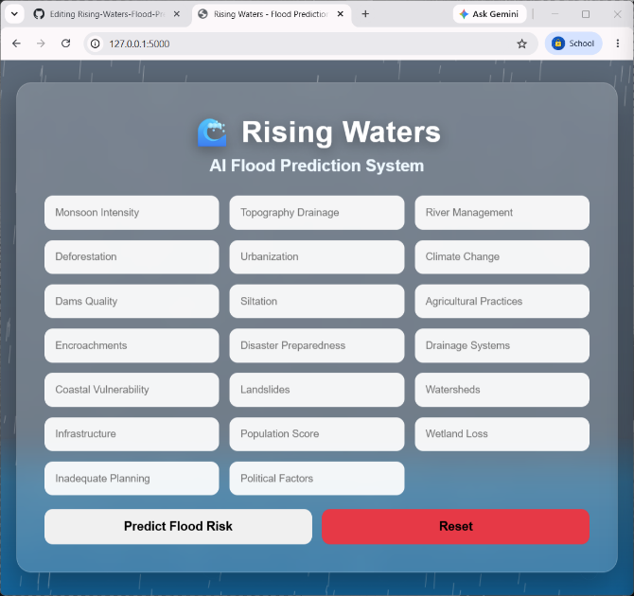
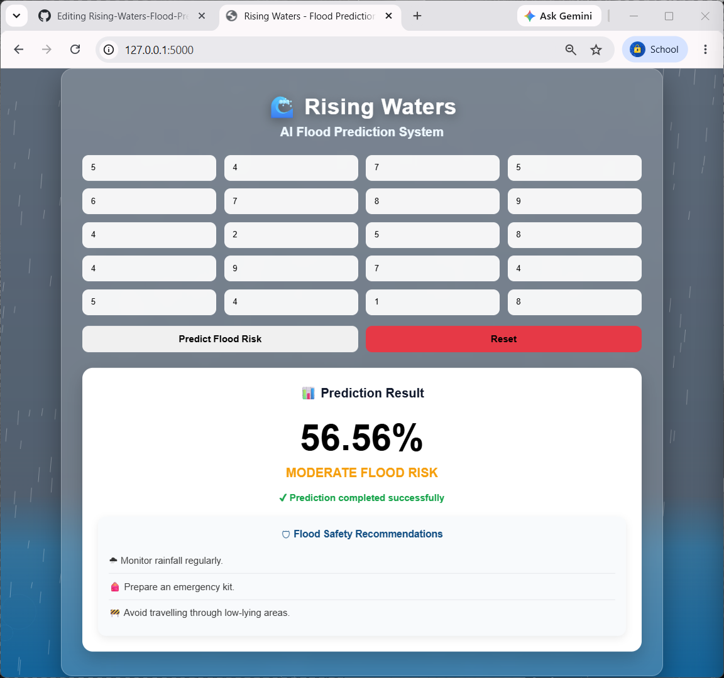 | 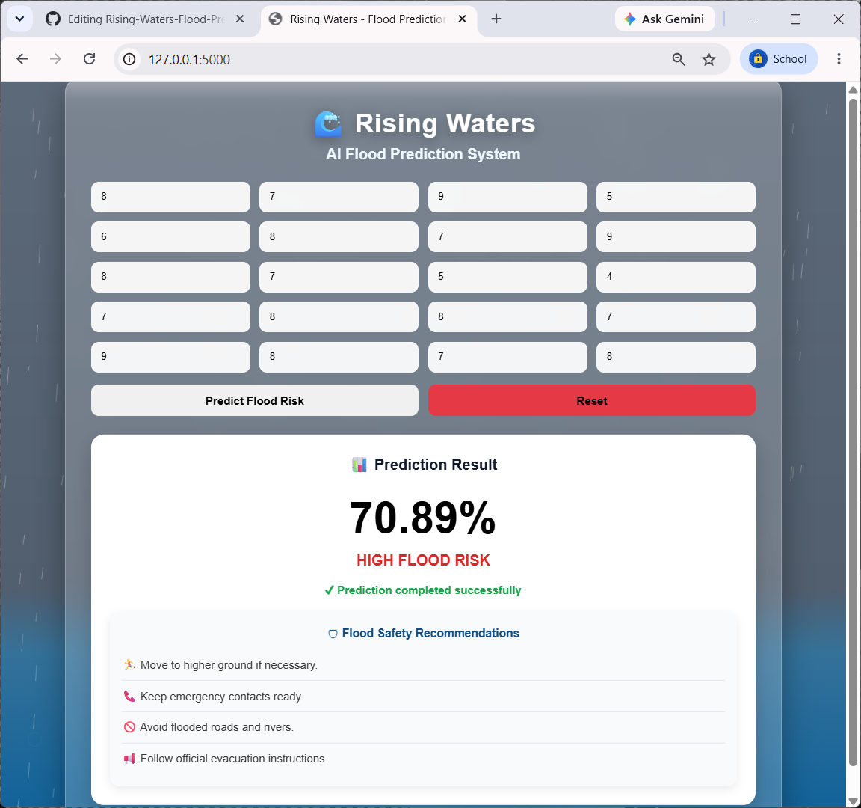

8. ADVANTAGES & DISADVANTAGES
Advantages
- Provides early flood risk prediction.
- Supports disaster preparedness.
- User-friendly web interface.
- Fast and accurate predictions.
- Helps reduce property damage and improve public safety.
Disadvantages
- Prediction accuracy depends on data quality.
- Requires internet connectivity for weather APIs.
- Performance may decrease with inaccurate or missing data.
- Requires periodic model retraining.
9. CONCLUSION
The Rising Waters – AI Flood Prediction System successfully predicts flood risk using Machine Learning and environmental parameters. The system provides early warnings, safety recommendations, and an intuitive web interface that helps users make informed decisions during flood situations. This project demonstrates the practical application of Artificial Intelligence in disaster management and public safety.

10. FUTURE SCOPE
The system can be enhanced by integrating IoT sensors for real-time monitoring, satellite imagery for improved prediction accuracy, mobile application support, SMS and email alert services, and deep learning models for advanced flood forecasting. These improvements will make the system more scalable and reliable.
11. APPENDIX
Source Code: https://github.com/BASITH2602/Rising-Waters-Flood-Prediction
Dataset: https://github.com/BASITH2602/Rising-Waters-Flood-Prediction/tree/main/dataset
Project Demo: https://rising-waters-flood-prediction-vjv5.onrender.com

